The homepage (figure 1) is the first interaction the customer has with the website. Here the user can see some positive feedback from our staff and patients and can choose to sign in by clicking on the SIGN IN button on the top right corner of the page. This button redirects the user from the index page (<https://zeno.computing.dundee.ac.uk/2018-ac32006/team18/index.php>) to the sign in page (<https://zeno.computing.dundee.ac.uk/2018-ac32006/team18/login.php>). If the guest decides that they want to take another look at our amazingly designed homepage, they can click on the “Back to home button”.

The sign in page, presented in figure 2 is an all-purpose sign in page. All the different types of users can sign in using this page. In case the guest is not a registered patient and they would like to be, the “Don’t have an account?” option sends them to the Register page (<https://zeno.computing.dundee.ac.uk/2018-ac32006/team18/Register.php> -figure 3), where they can enter all their details in the form provided. When the guest touches the register button all the details are being uploaded to the database under a new entry in the patients table. After signing up on the previous link (pressing the “Register” button –figure 4) the new patient is redirected to the homepage where they can choose to select the sign in option and they will be able to log in using the email and password they chose at the previous step.

In the case of a registered user (such as a patient or doctor) the sign in process is as straight forward as it gets. The user has to type in an email address and a password. The system checks if they are stored in the database. If they are not, the user is prompted to add type the email address and password again. If the email address and password were found to be stored in one of the tables, the registered user is admitted to the part of the website they are permitted to access.

Patients are allowed to view the following pages:

<https://zeno.computing.dundee.ac.uk/2018-ac32006/team18/patient/test.php> -figure 5, 6, 7

Where they can see a list of all the tests available to them. In the bottom right area of the page, the patients can book an appointment for the test they choose, at the date that best suits their schedule. By clicking Submit, the user triggers the system to create an entry in the appointments table.

[https://zeno.computing.dundee.ac.uk/2018-ac32006/team18/patient/Results.php](https://zeno.computing.dundee.ac.uk/2018-ac32006/team18/patient/Results.php%20)  -figure 8

This page allows patients to look at results of previous tests. In case the results are not ready yet, the results field will show “Pending”.

<https://zeno.computing.dundee.ac.uk/2018-ac32006/team18/patient/myDetails.php> -figure 9

The myDetails page gives the patients the opportunity to check or change their details with an immediate update on the database itself. Any changes made in the form presented on this page will be sent to the database and stored.

<https://zeno.computing.dundee.ac.uk/2018-ac32006/team18/patient/prescription.php> -figure 10

On the prescription page the patient has access to a list of any previous or current prescriptions.

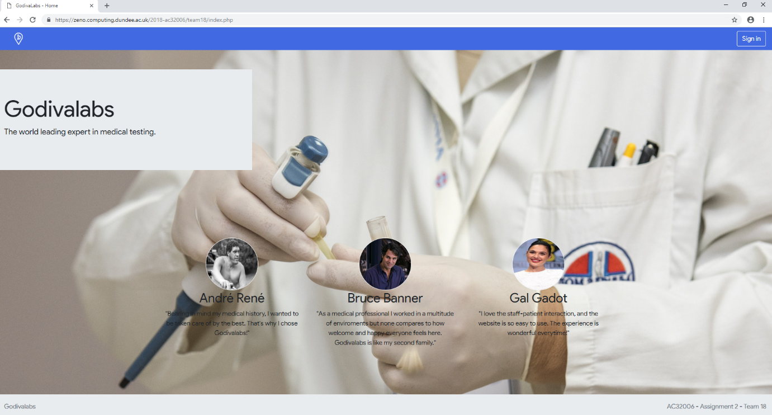

Figure 1

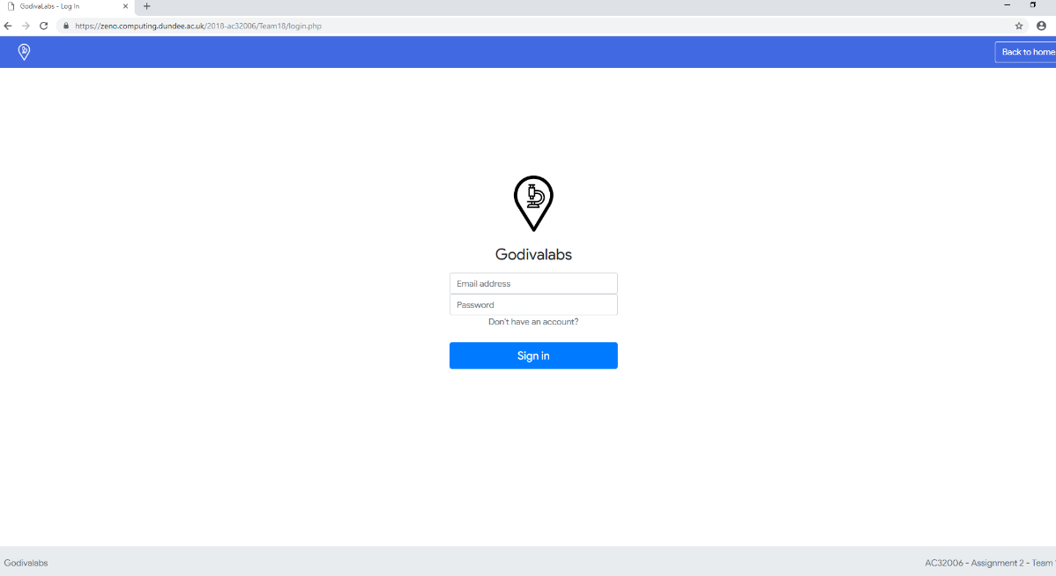

Figure 2

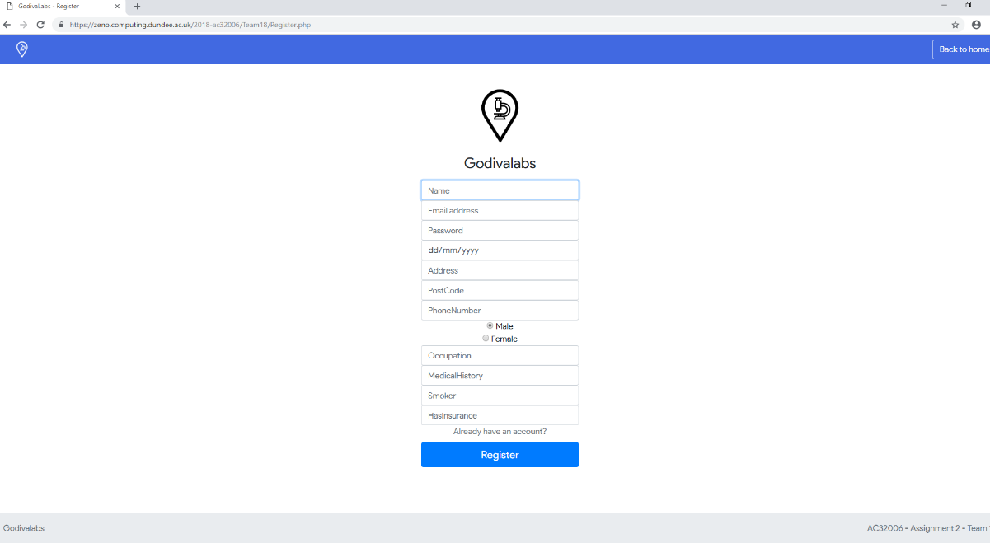

Figure 3

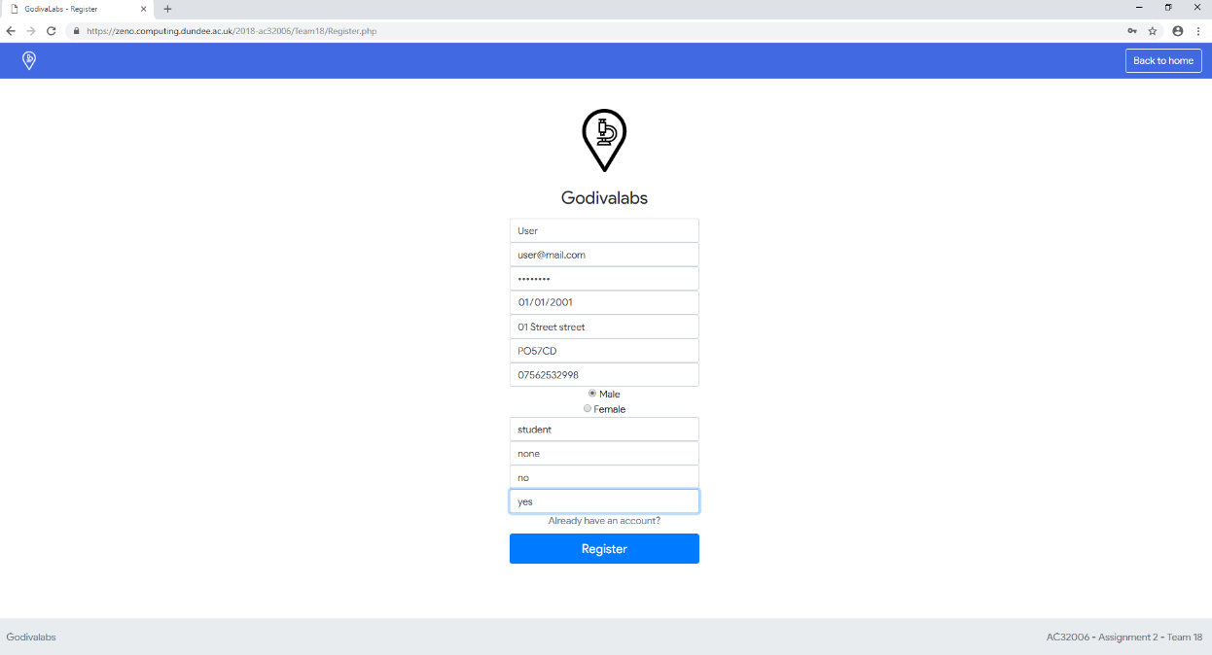

Figure 4

